**27-12-2024**

**1. Find Maximum and Minimum in an Array**

**\* Problem Statement: Write a program to find the maximum and minimum values in a single-dimensional array of integers. Use: A const variable for the array size.**

**\* A static variable to keep track of the maximum difference between the maximum and minimum values.if statements within a for loop to determine the maximum and minimum values.**

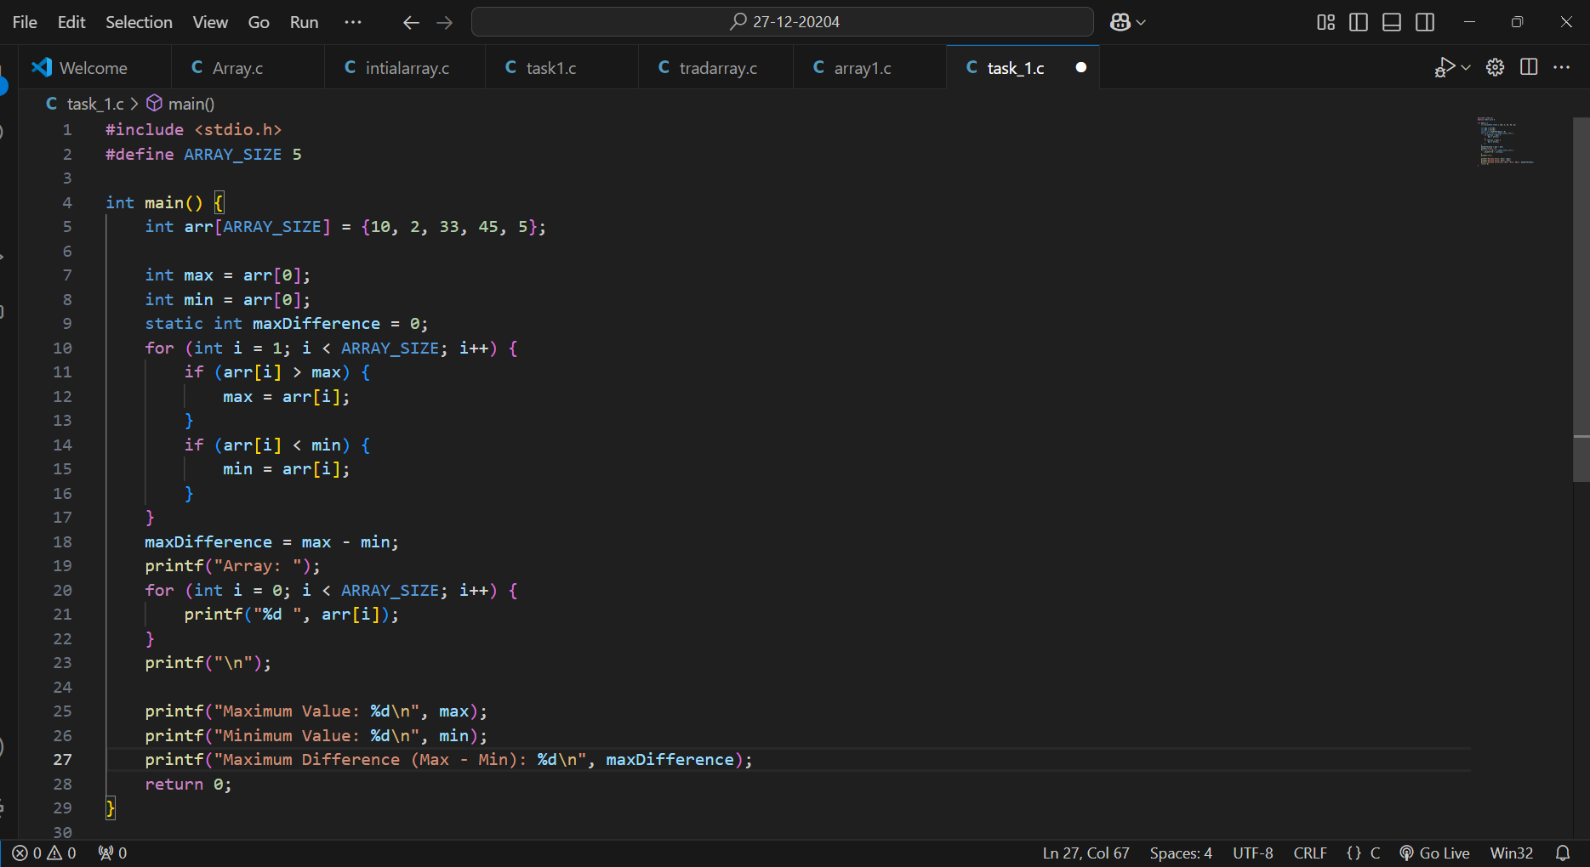

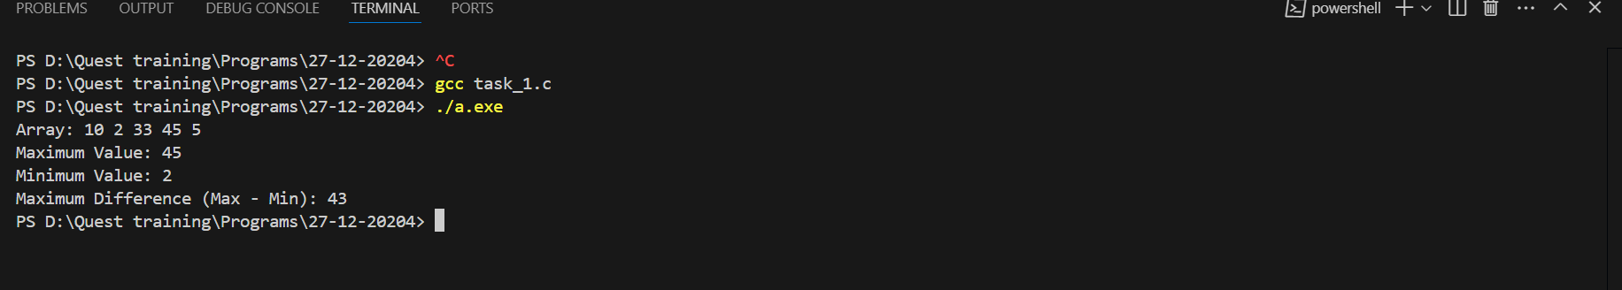

**2. Array Element Categorization**

**\* Problem Statement: Categorize elements of a single-dimensional array into positive, negative, and zero values. Use:**

**\* A const variable to define the size of the array.**

**\* A for loop for traversal.**

**\* if-else statements to classify each element into separate arrays using static storage.**

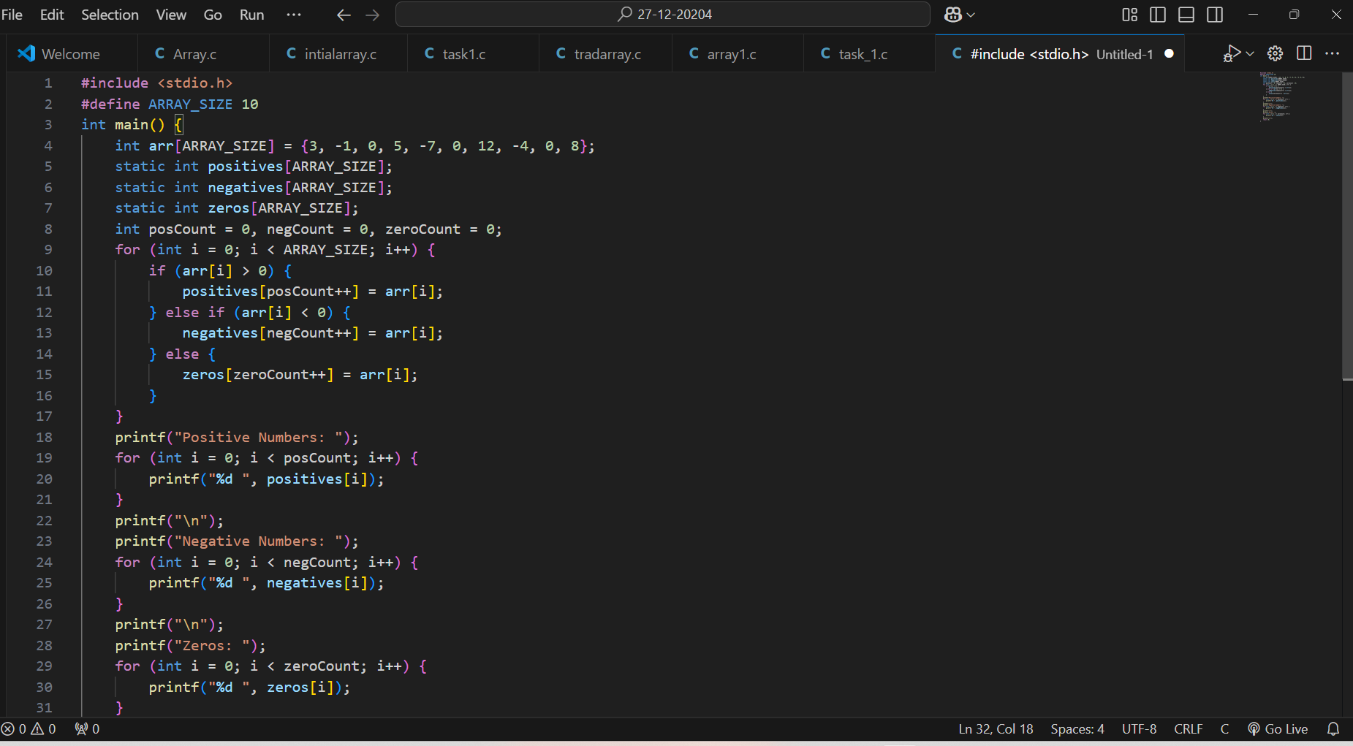

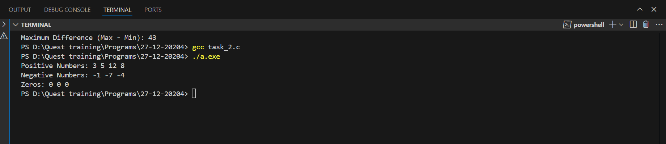

**3. Cumulative Sum of Array Elements**

**\* Problem Statement: Calculate the cumulative sum of elements in a single-dimensional array. Use:**

**\* A static variable to hold the running total. A for loop to iterate through the array and update the cumulative sum.A const variable to set the array size.**

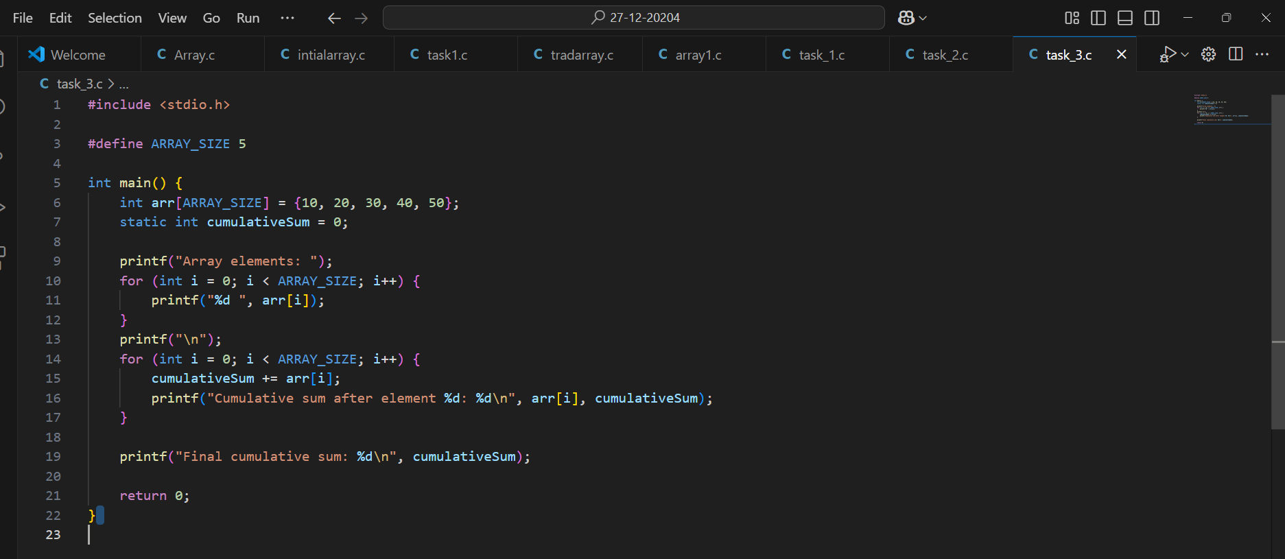

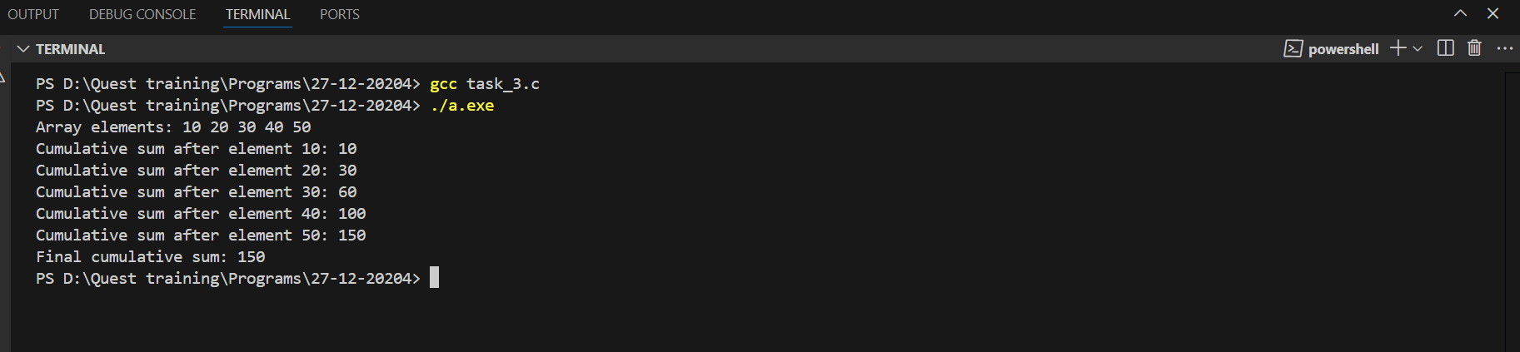

**4. Check Prime Numbers in an Array**

**\* Problem Statement: Identify which elements in a single-dimensional array are prime numbers. Use: A for loop to iterate through the array and check each element. A nested for loop to determine if a number is prime. if statements for decision-making. A const variable to define the size of the array.**

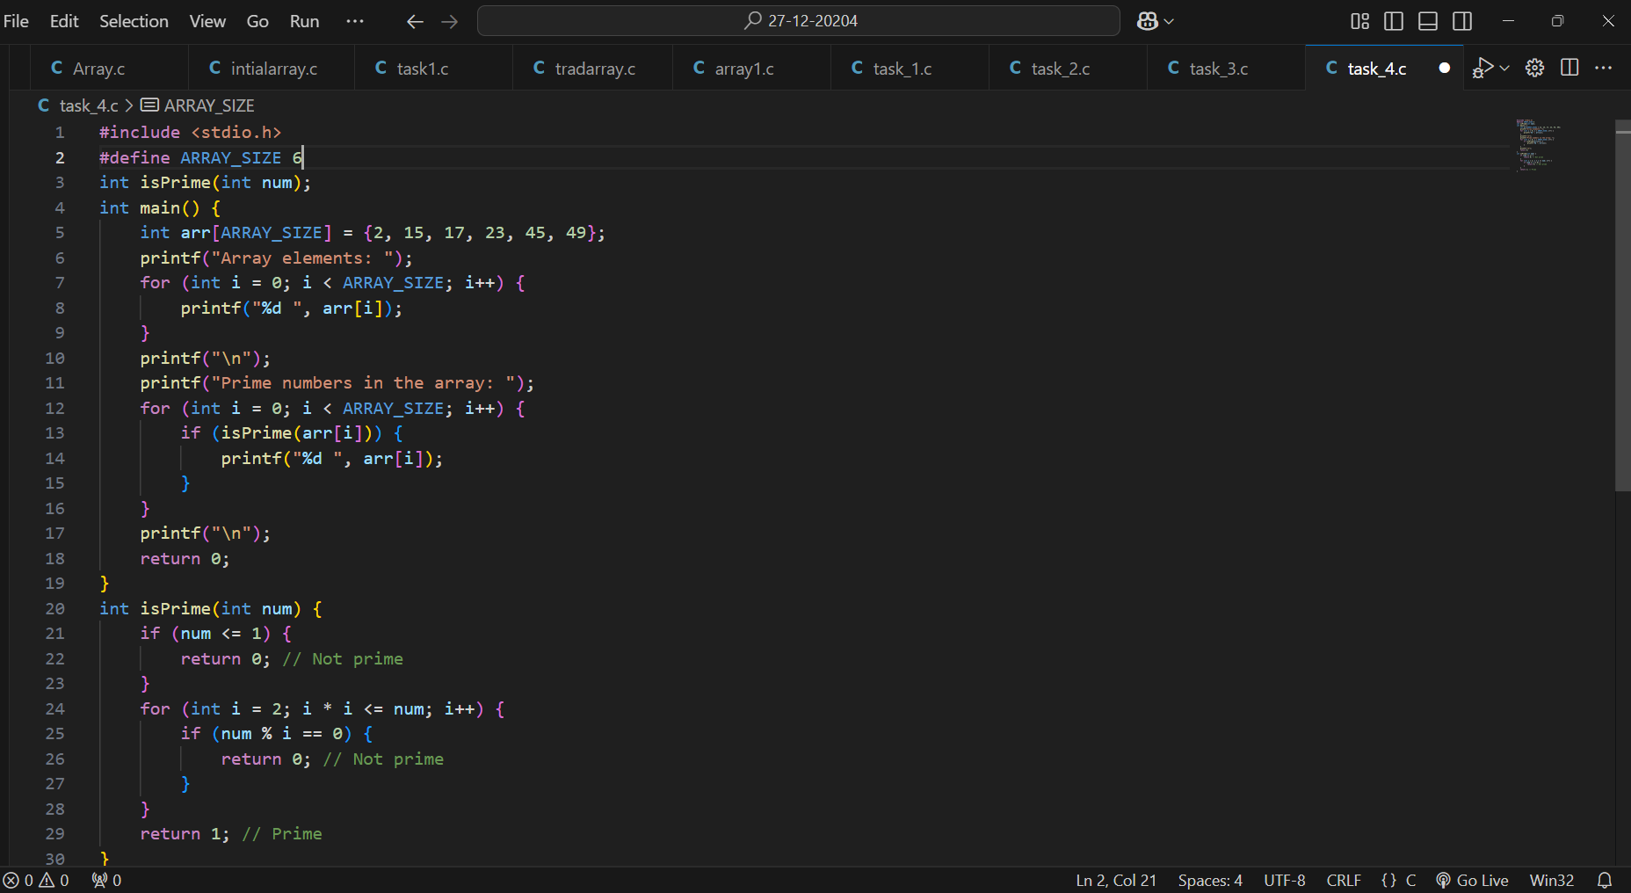

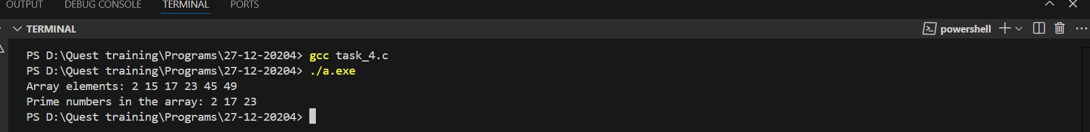

**5. Array Rotation by N Positions.**

**\* Problem Statement: Rotate the elements of a single-dimensional array to the left by N positions. Use: A const variable for the rotation count. A static array to store the rotated values. A while loop for performing the rotation.**

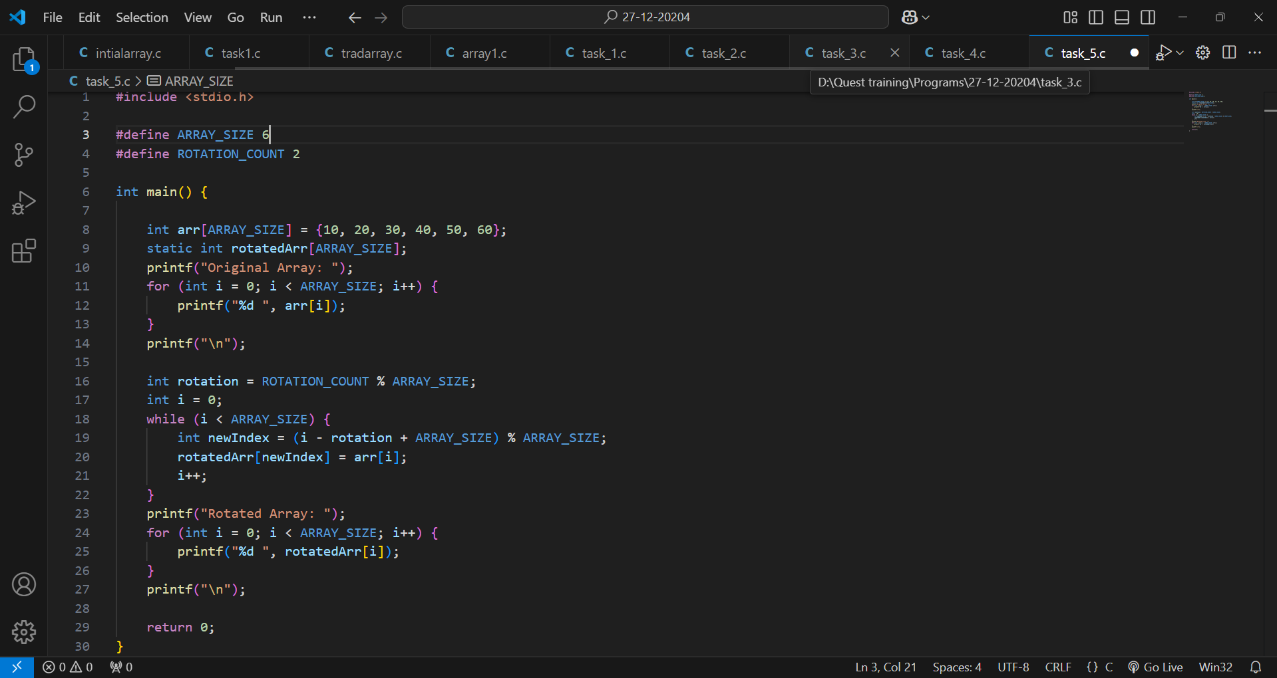

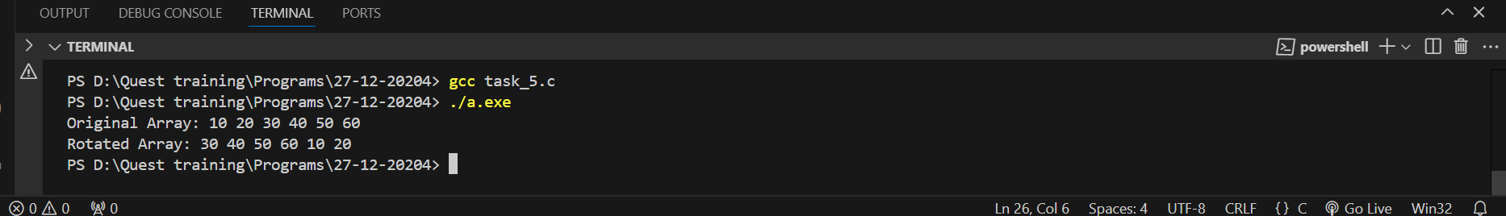

**6. Count Frequency of Each Element - Problem Statement: Count the frequency of each unique element in a single-dimensional array. Use: A const variable for the size of the array. A nested for loop to compare each element with the rest.**

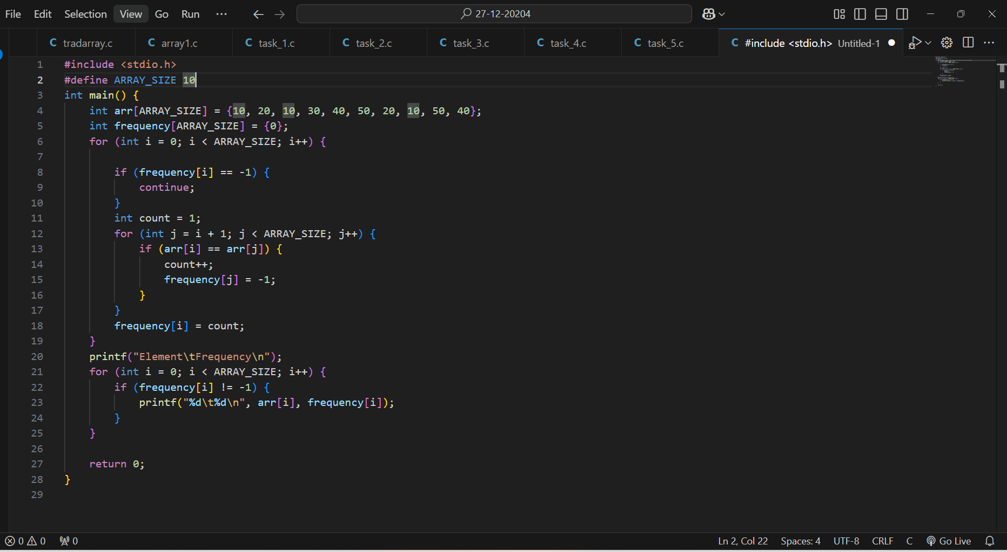

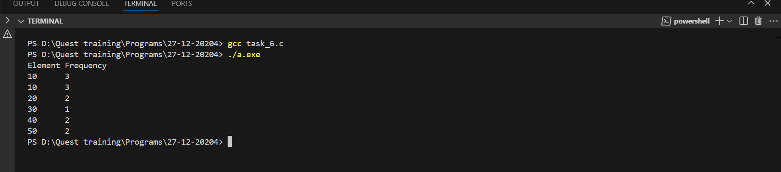

**7. Sort Array in Descending Orde**

**\* Problem Statement: Sort a single-dimensional array in descending order using bubble sort. Use:**

**\* A const variable for the size of the array A nested for loop for sorting if statements for comparing and swapping elements.**

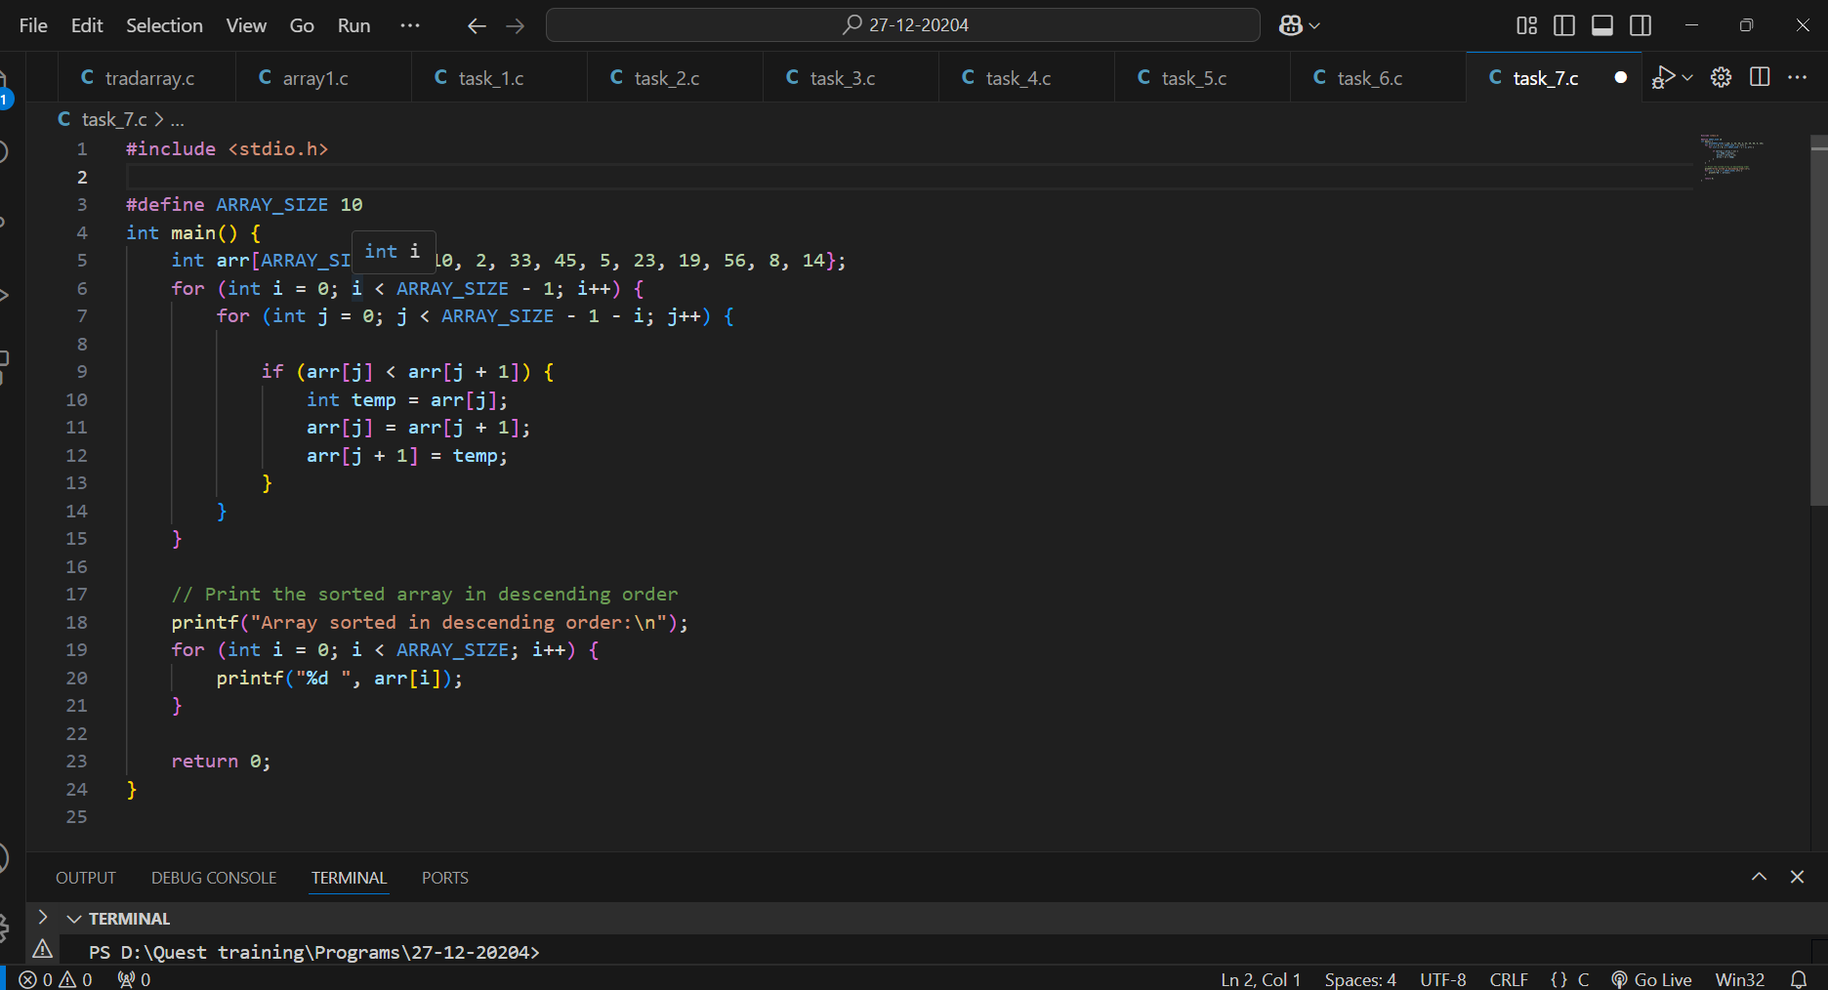

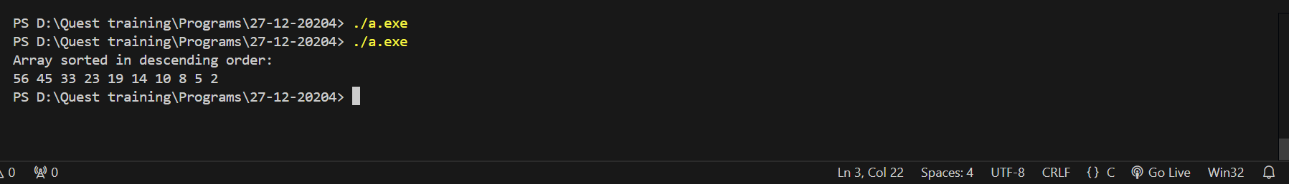

**8. Find the Second Largest Element**

**\* Problem Statement: Find the second largest element in a single-dimensional array. Use:**

**\* A const variable for the array size. A static variable to store the second largest element.**

**\* if statements and a single for loop to compare elements.**

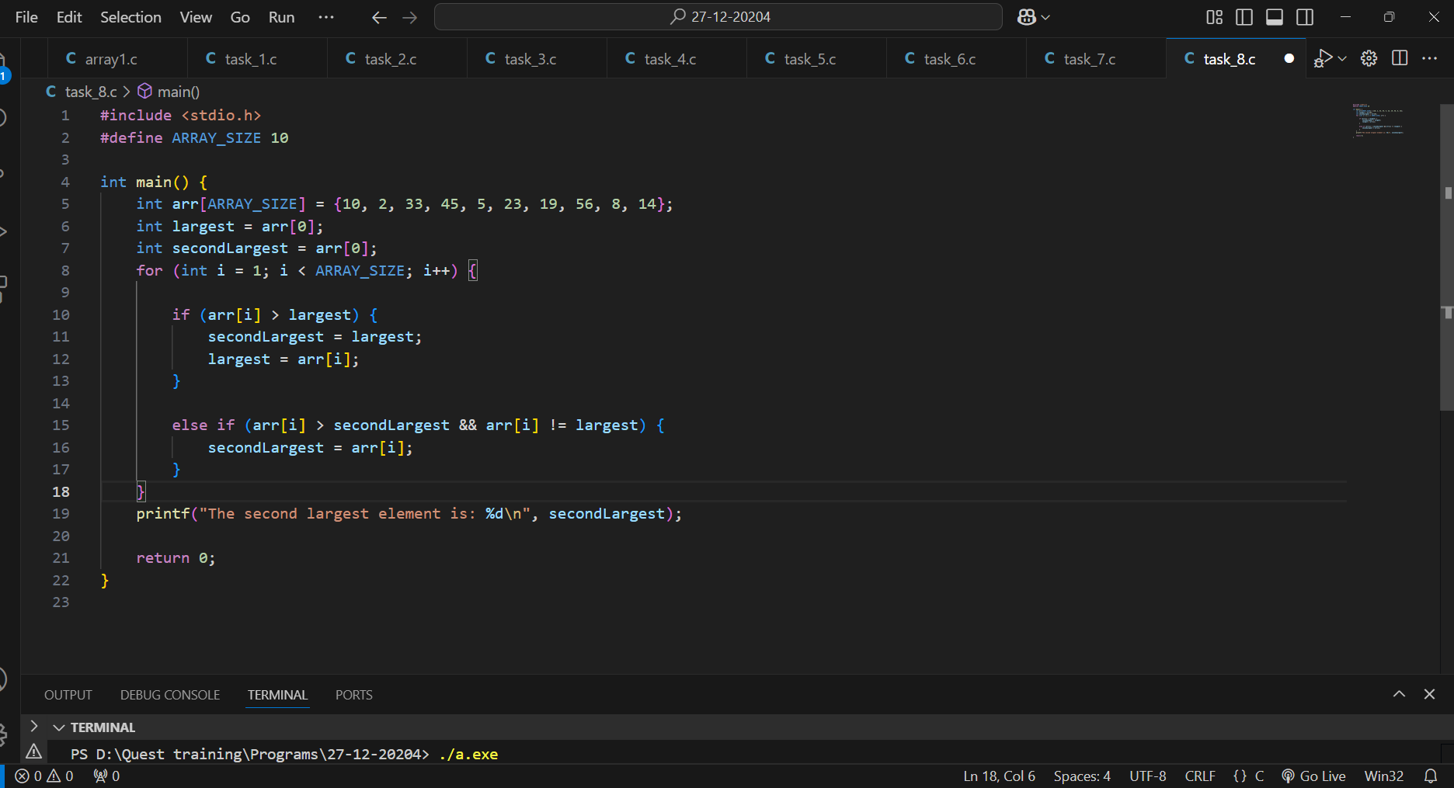

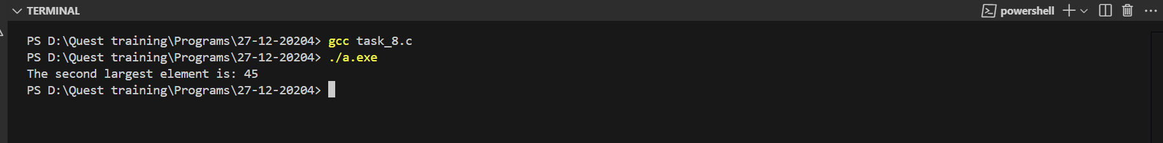

**9. Odd and Even Number Separation**

**\* Problem Statement: Separate the odd and even numbers from a single-dimensional array into two separate arrays. Use: A const variable for the size of the array. if-else statements to classify elements.A for loop for traversal and separation.**

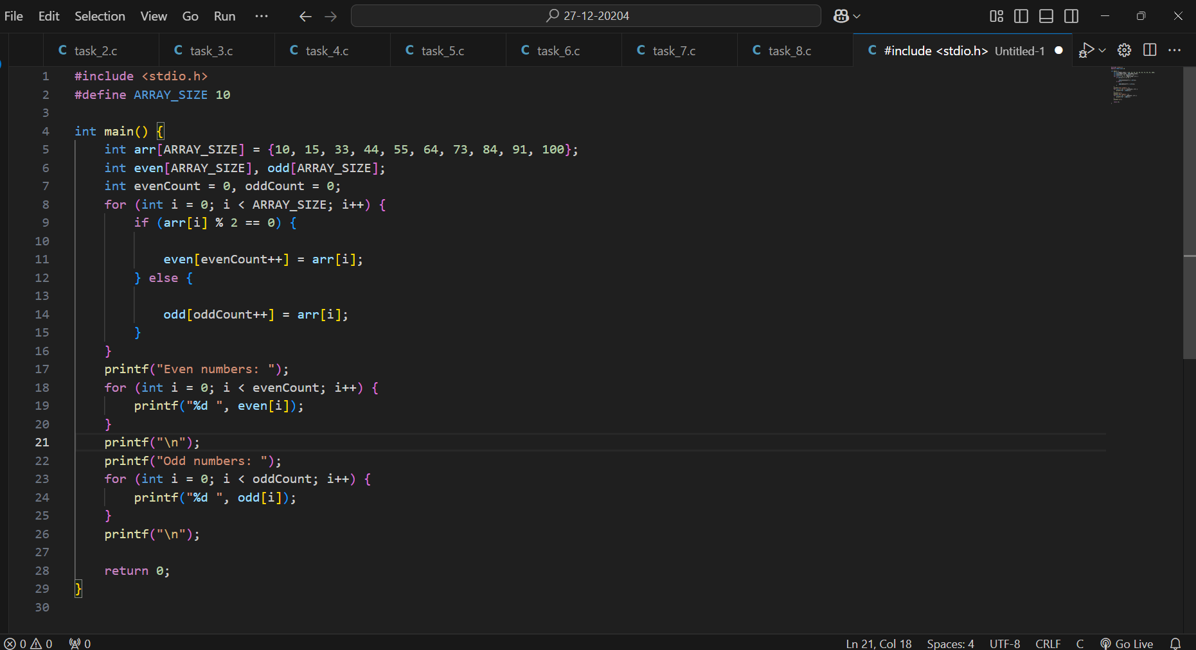

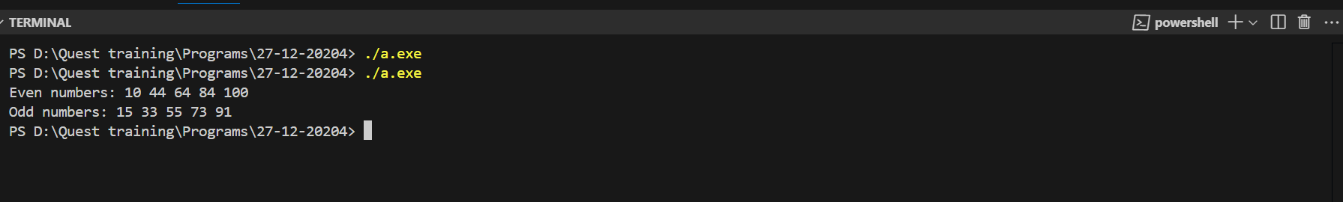

**10. Cyclically Shift Array Elements**

**\* Problem Statement: Shift all elements of a single-dimensional array cyclically to the right by one position. Use: A const variable for the array size. A static variable to temporarily store the last element during shifting. A for loop for the shifting operation.**

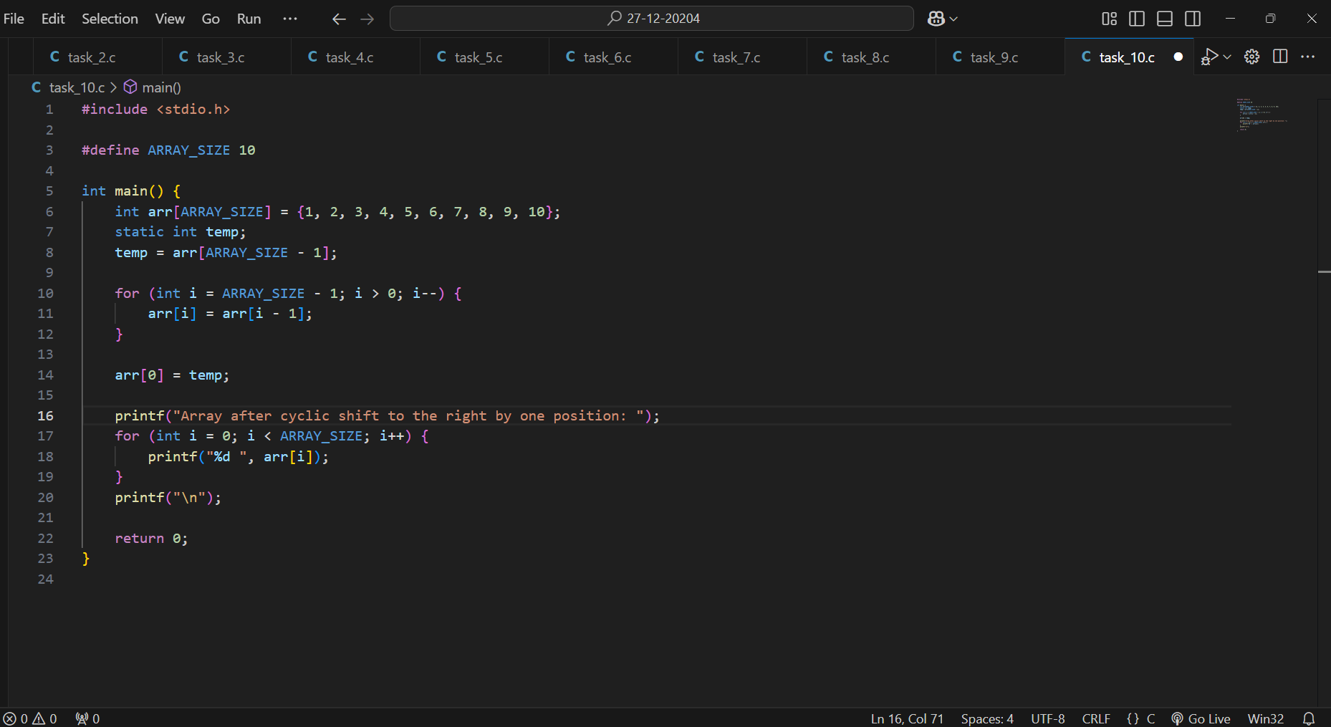

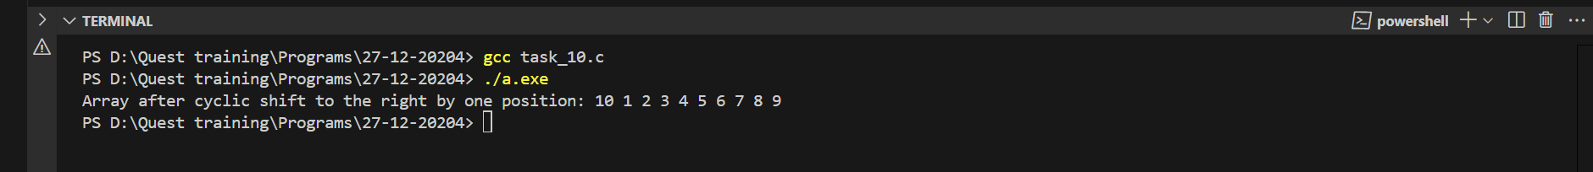

**Problem Statements on 2 Dimensional Arrays**

**1. Matrix Addition**

**Problem Statement: Write a program to perform the addition of two matrices. The program should: Take two matrices as input, each of size M x N, where M and N are defined using const variables.Use a static two-dimensional array to store the resulting matrix. Use nested for loops to perform element-wise addition.Use if statements to validate that the matrices have the same dimensions before proceeding with the addition.**

**Requirements: Declare matrix dimensions as const variables. Use decision-making constructs to handle invalid dimensions.Print the resulting matrix after addition.**

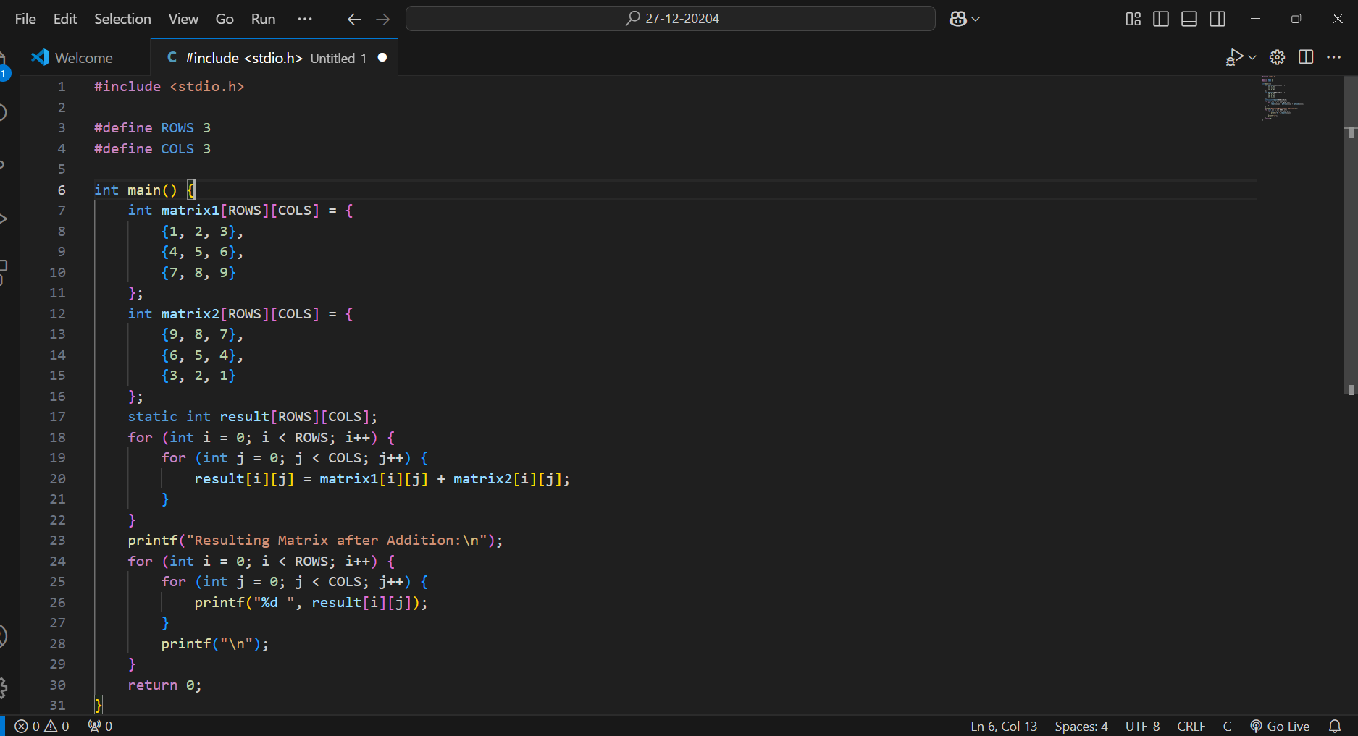

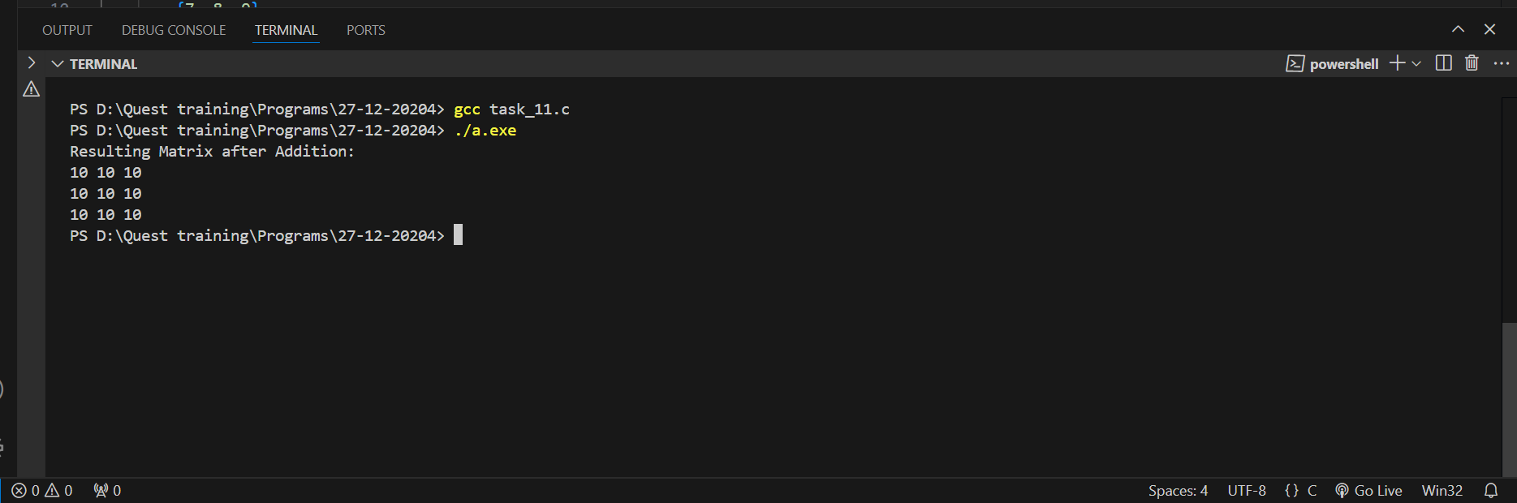

**2. Transpose of a Matrix**

**\* Problem Statement: Write a program to compute the transpose of a matrix. The program should: Take a matrix of size M x N as input, where M and N are declared as const variables.Use a static two-dimensional array to store the transposed matrix.Use nested for loops to swap rows and columns Validate the matrix size using if statements before transposing.**

**\* Requirements: Print the original and transposed matrices.Use a type qualifier (const) to ensure the matrix size is not modified during execution.**

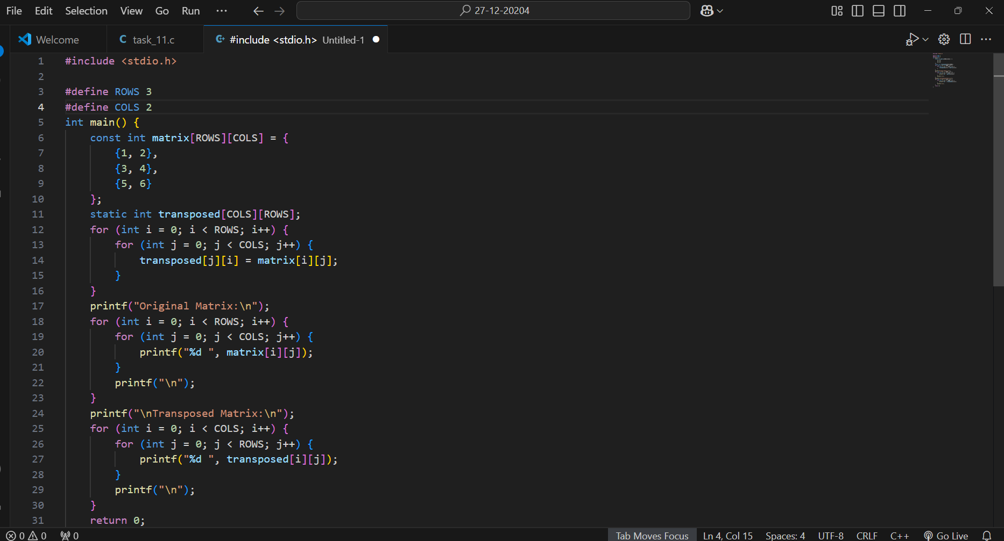

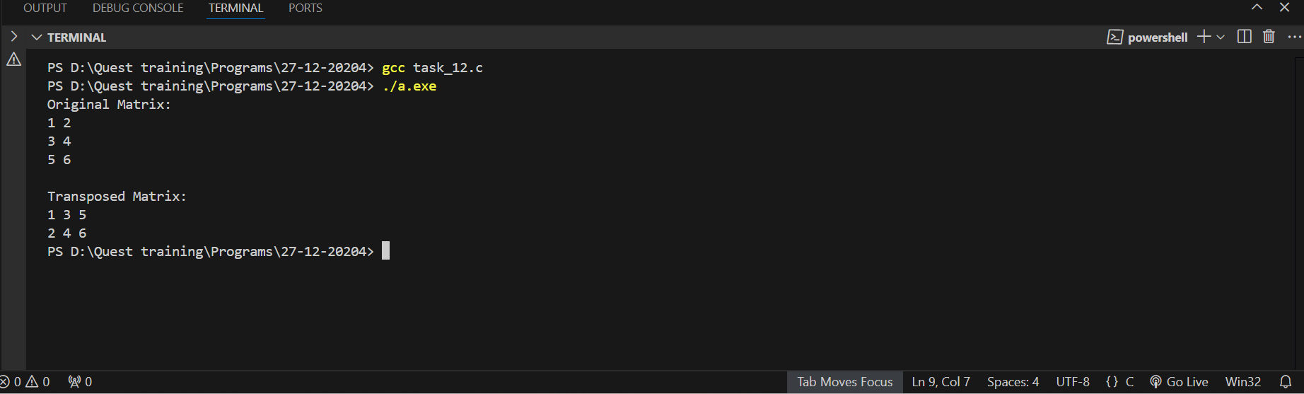

**3. Find the Maximum Element in Each Row**

**\* Problem Statement: Write a program to find the maximum element in each row of a two-dimensional array. The program should:Take a matrix of size M x N as input, with dimensions defined using const variables. Use a static array to store the maximum value of each row. Use nested for loops to traverse each row and find the maximum element.Use if statements to compare and update the maximum value.**

**\* Requirements:**

**Print the maximum value of each row after processing the matrix.**

**Handle edge cases where rows might be empty using decision-making statements.**

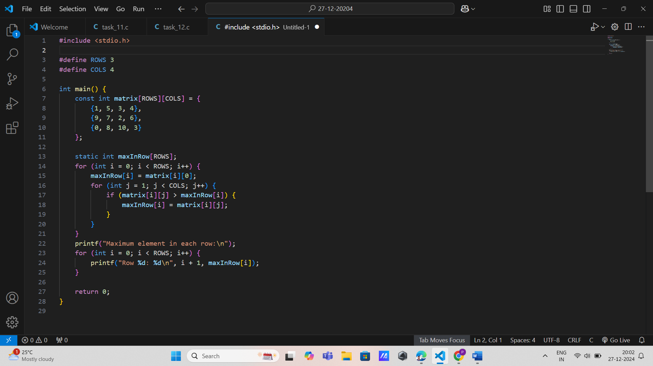

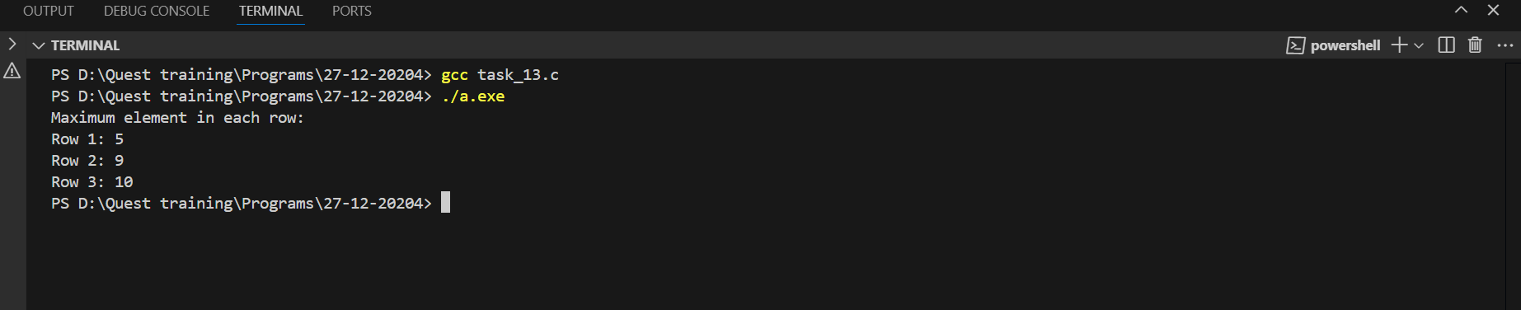

**4. Matrix Multiplication**

**\* Problem Statement: Write a program to multiply two matrices. The program should: Take two matrices as input: Matrix A of size M x N Matrix B of size N x P Use const variables to define the dimensions M, N, and P. Use nested for loops to calculate the product of the matrices. Use a static two-dimensional array to store the resulting matrix.Use if statements to validate that the matrices can be multiplied (N in Matrix A must equal M in Matrix B).**

**\* Requirements:**

**Print both input matrices and the resulting matrix.**

**Handle cases where multiplication is invalid using decision-making constructs.**

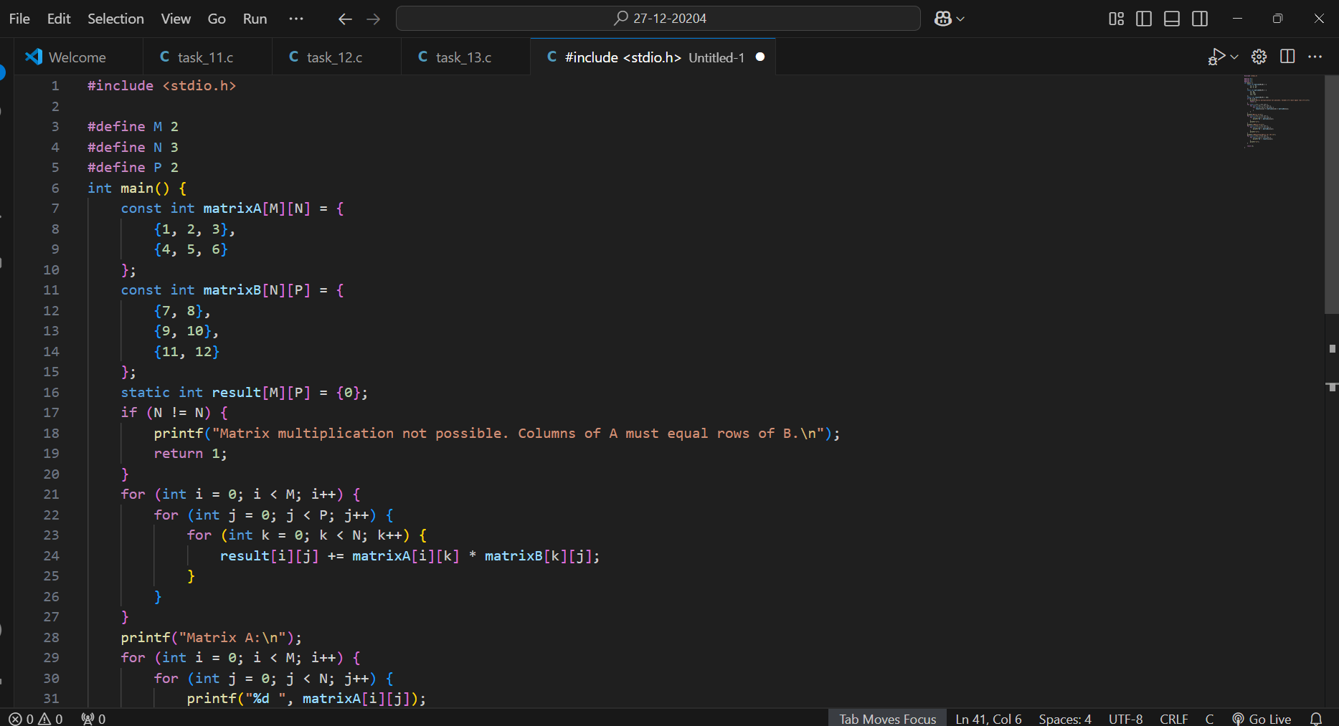

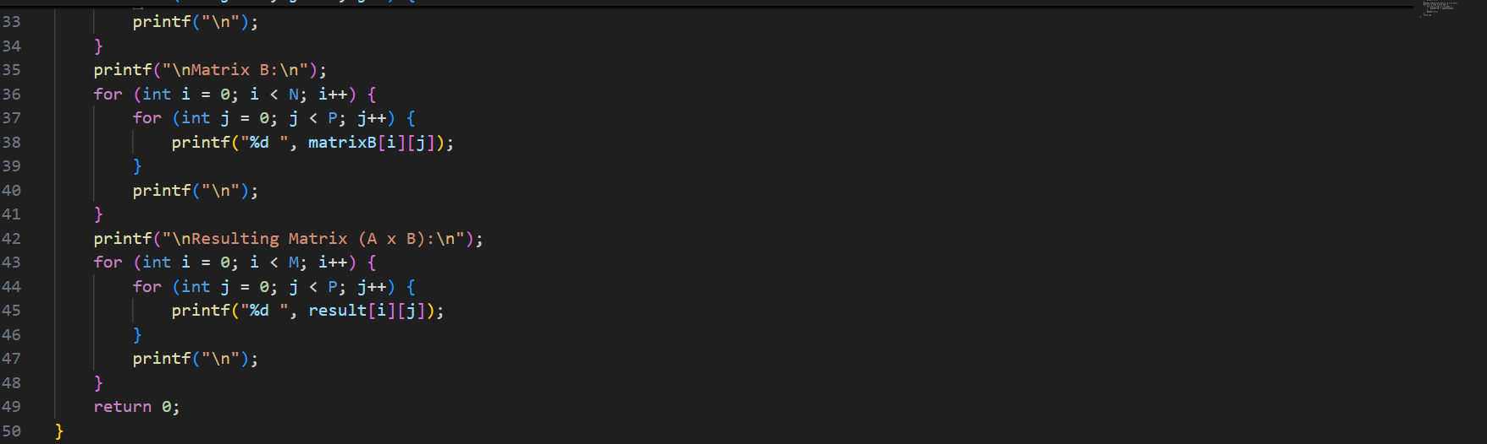

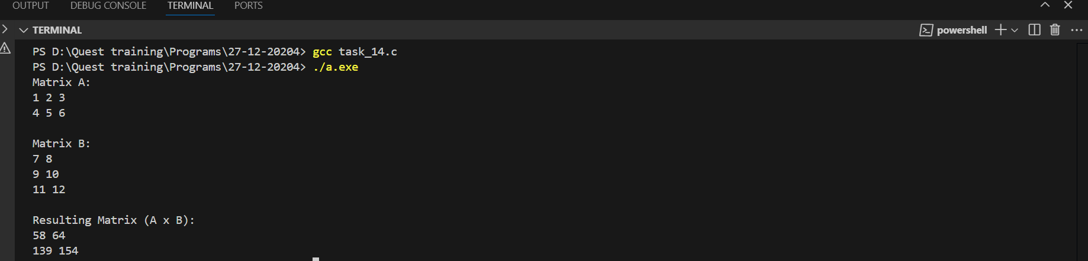

**5. Count Zeros in a Sparse Matrix**

**Problem Statement: Write a program to determine if a given matrix is sparse. A matrix is sparse if most of its elements are zero. The program should: Take a matrix of size M x N as input, with dimensions defined using const variables.Use nested for loops to count the number of zero elements. Use if statements to compare the count of zeros with the total number of elements.Use a static variable to store the count of zeros.**

**\* Requirements: Print whether the matrix is sparse or not.**

**Use decision-making statements to handle matrices with no zero elements.Validate matrix dimensions before processing.**

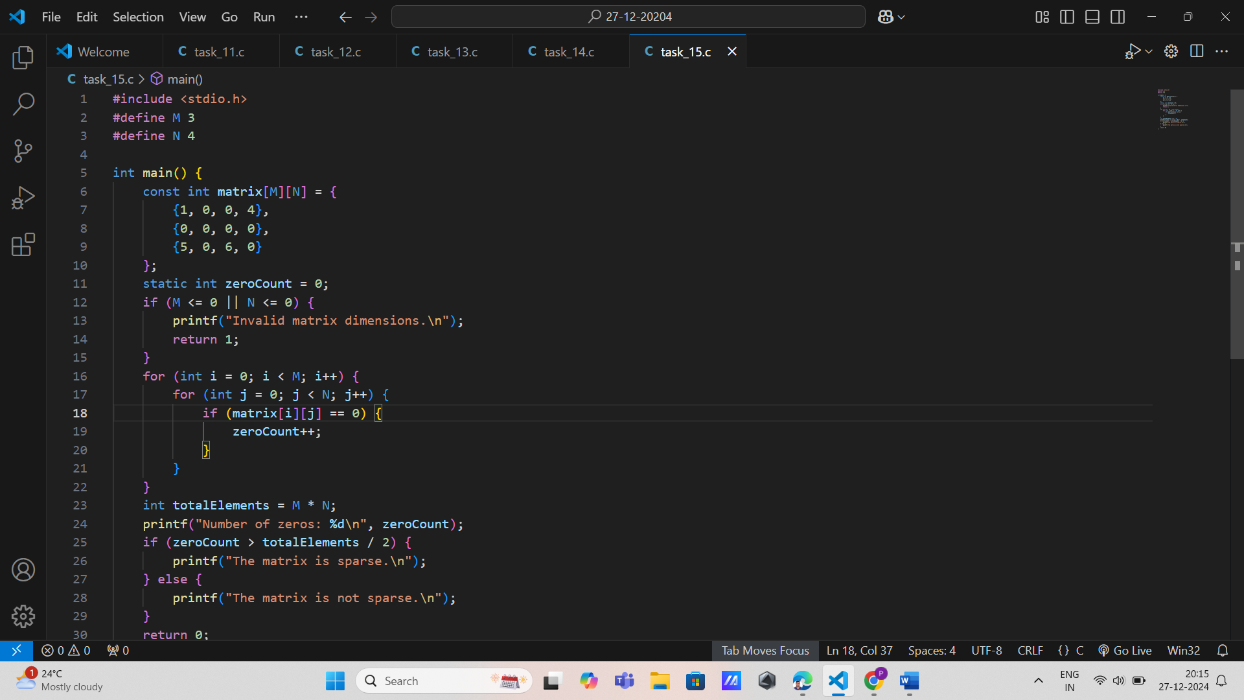

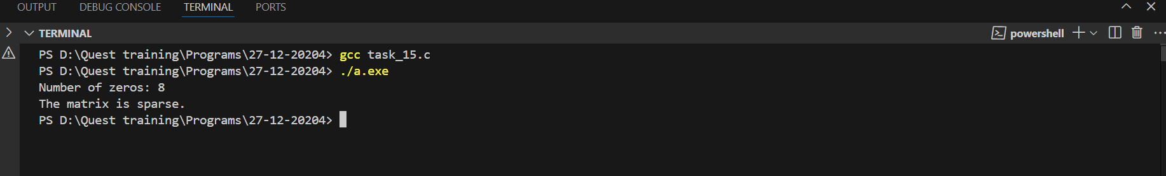

**Problem Statements on 3 Dimensional Arrays**

**1. 3D Matrix Addition**

**Problem Statement: Write a program to perform element-wise addition of two three-dimensional matrices. The program should: Take two matrices as input, each of size X x Y x Z, where X, Y, and Z are defined using const variables. Use a static three-dimensional array to store the resulting matrix. Use nested for loops to iterate through the elements of the matrices. Use if statements to validate that the dimensions of both matrices are the same before performing addition.**

**Requirements: Declare matrix dimensions as const variables.**

**Use decision-making statements to handle mismatched dimensions.**

**Print the resulting matrix after addition.**

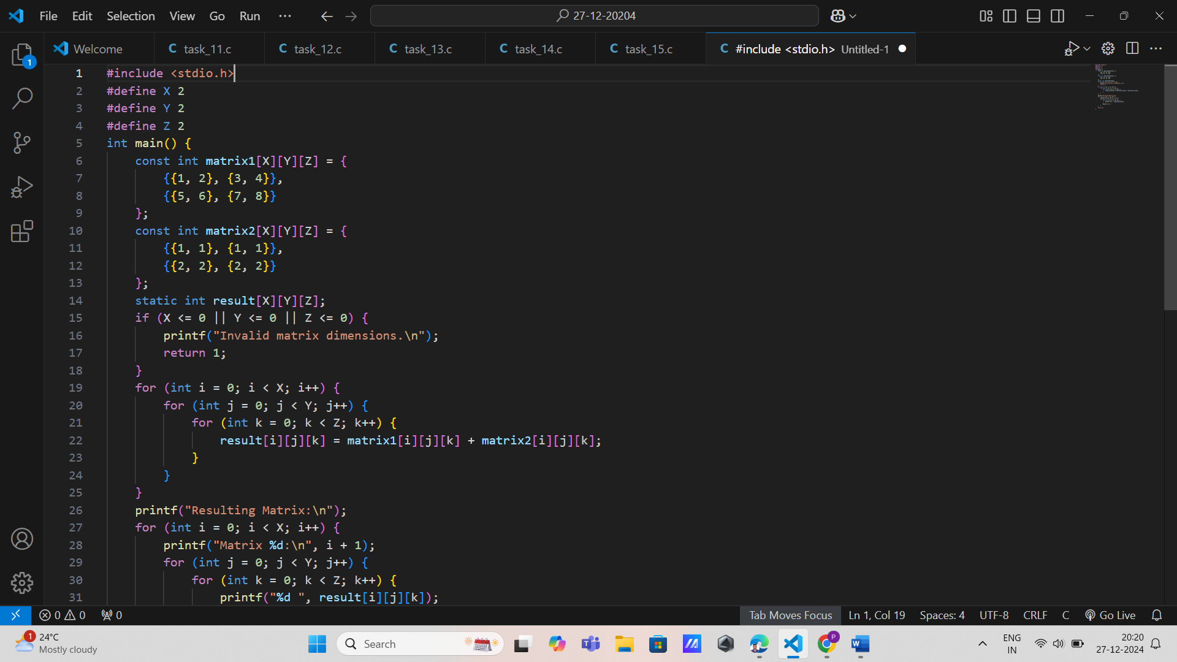

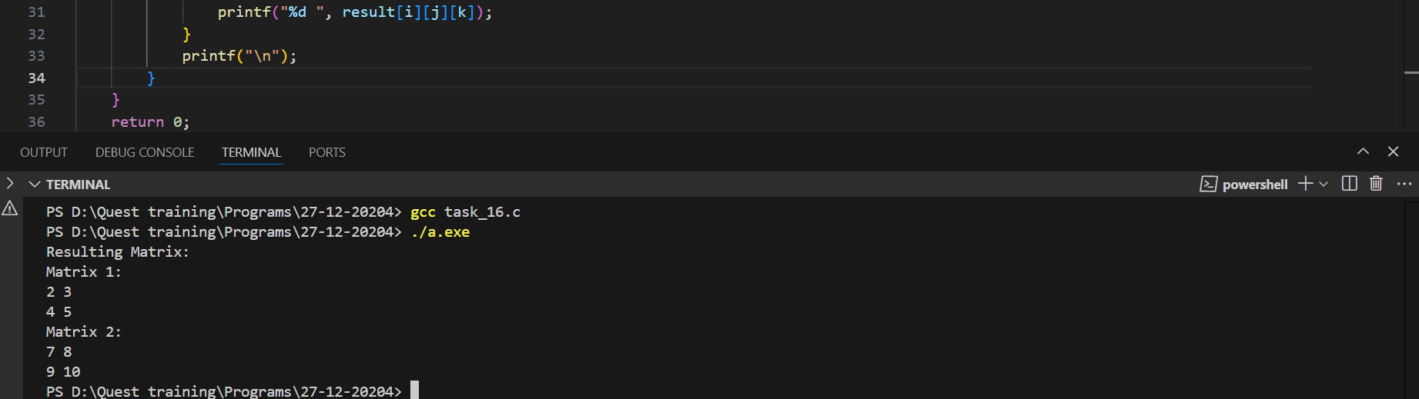

**2. Find the Maximum Element in a 3D Array**

**Problem Statement: Write a program to find the maximum element in a three-dimensional matrix. The program should: Take a matrix of size X x Y x Z as input, where X, Y, and Z are declared as const variables. Use a static variable to store the maximum value found. Use nested for loops to traverse all elements of the matrix. Use if statements to compare and update the maximum value.**

**\* Requirements:**

**\* Print the maximum value found in the matrix.**

**\* Handle edge cases where the matrix might contain all negative numbers or zeros using decision-making statements.**

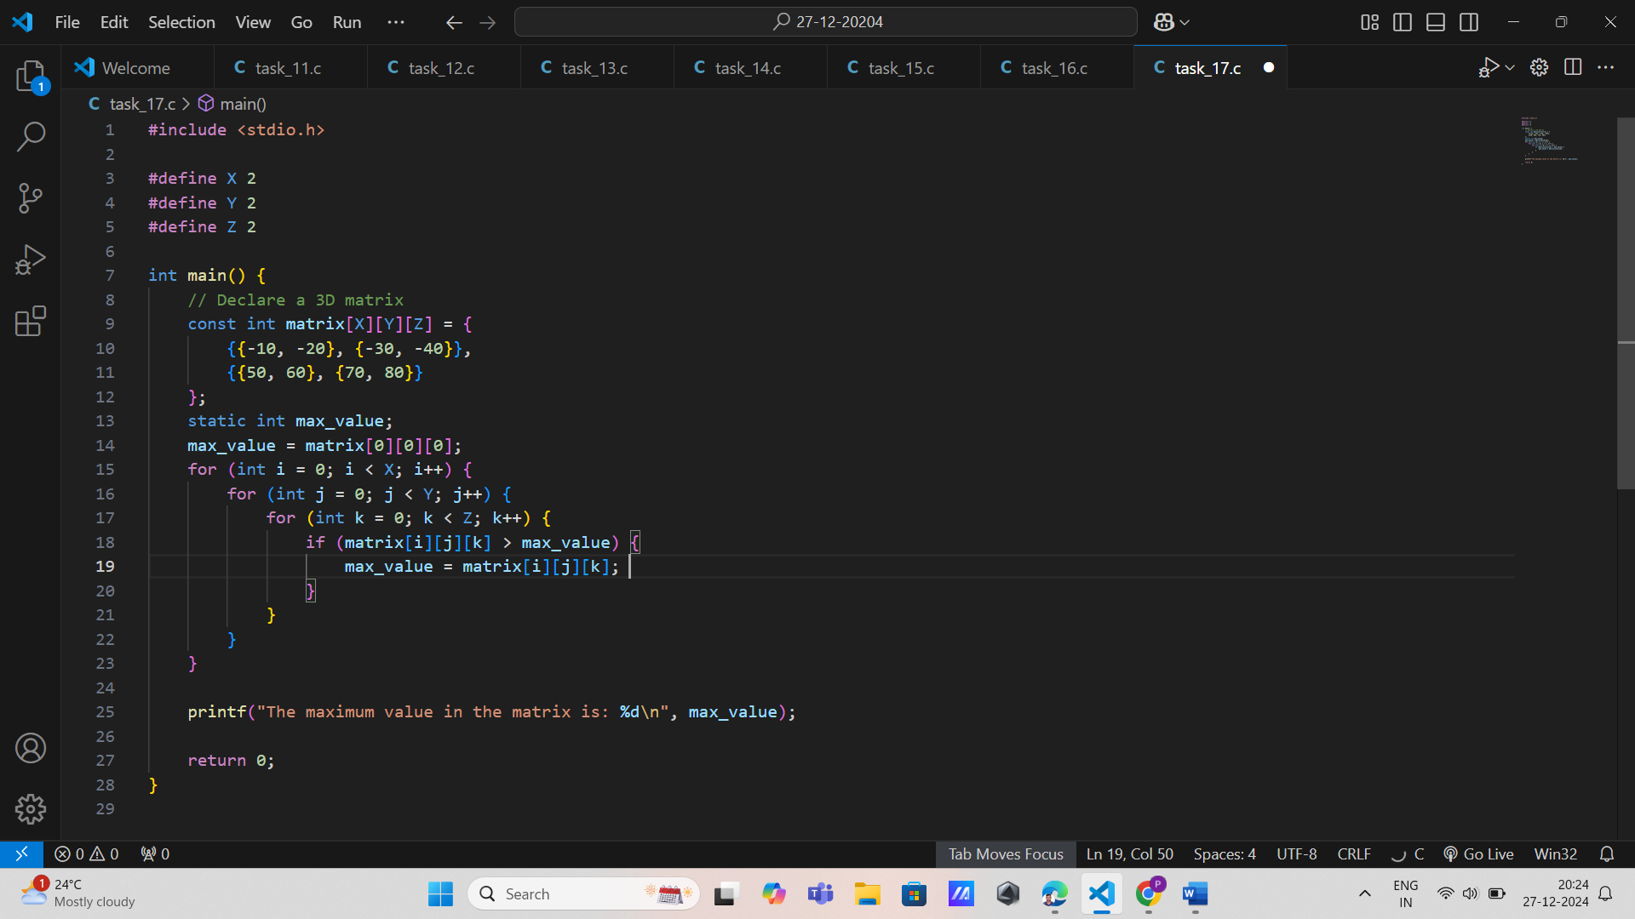

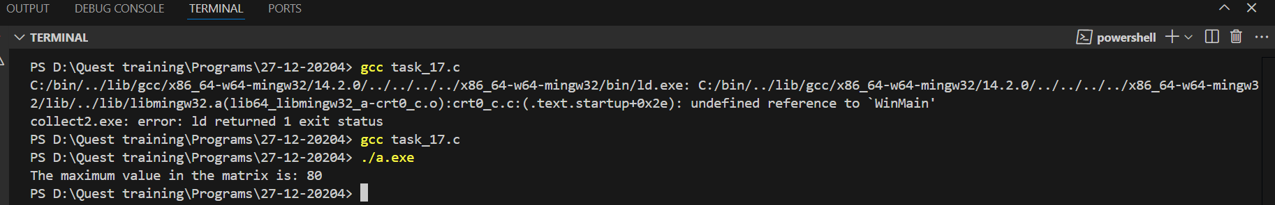

**3. 3D Matrix Scalar Multiplication**

**Problem Statement: Write a program to perform scalar multiplication on a three-dimensional matrix. The program should: Take a matrix of size X x Y x Z and a scalar value as input, where X, Y, and Z are declared as const variables.Use a static three-dimensional array to store the resulting matrix. Use nested for loops to multiply each element of the matrix by the scalar.**

**\* Requirements: Print the original matrix and the resulting matrix after scalar multiplication.Use decision-making statements to handle invalid scalar values (e.g., zero or negative scalars) if necessary.**

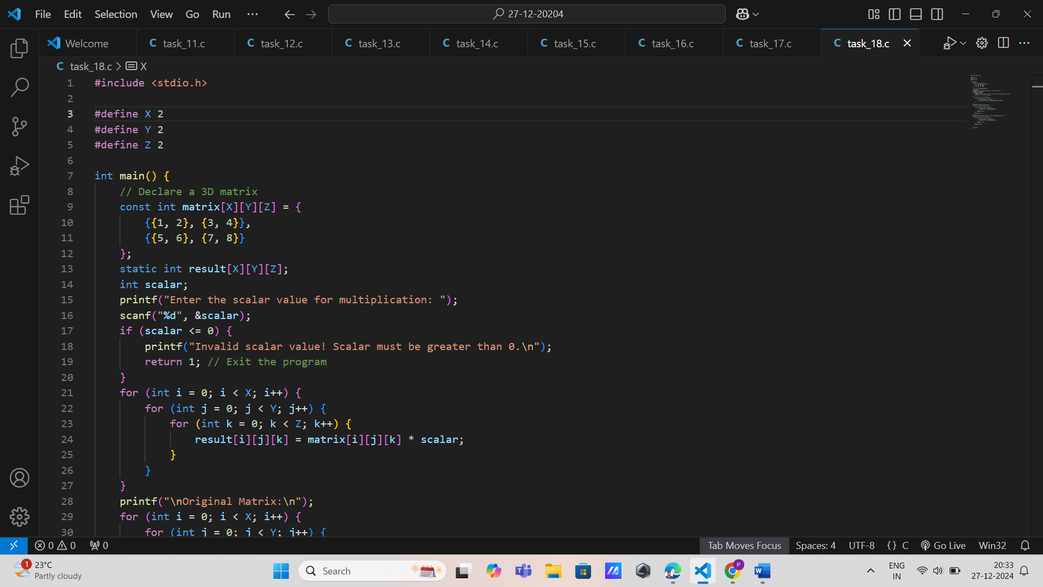

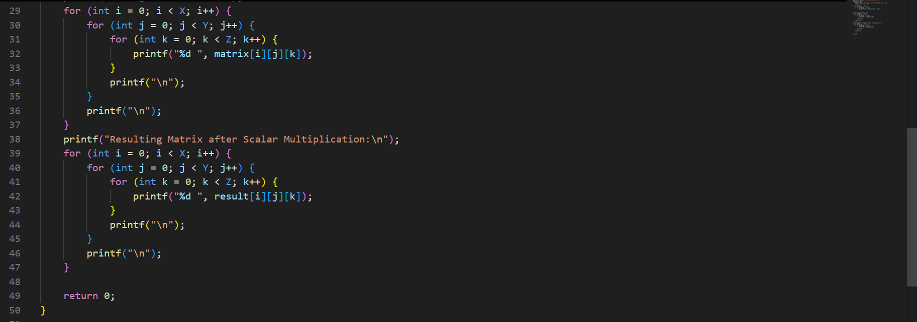

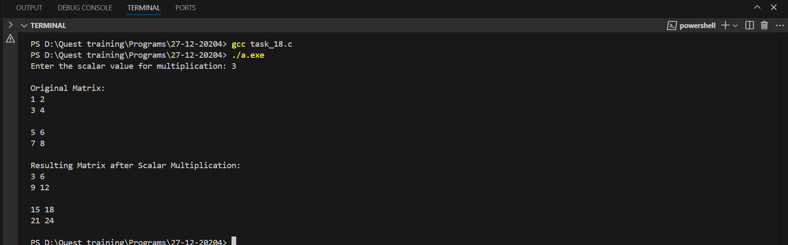

**4. Count Positive, Negative, and Zero Elements in a 3D Array**

**\* Problem Statement: Write a program to count the number of positive, negative, and zero elements in a three-dimensional matrix. The program should: Take a matrix of size X x Y x Z as input, where X, Y, and Z are defined using const variables. Use three static variables to store the counts of positive, negative, and zero elements, respectively. Use nested for loops to traverse the matrix. Use if-else statements to classify each element.**

**\* Requirements:**

**\* Print the counts of positive, negative, and zero elements**

**\* Ensure edge cases (e.g., all zeros or all negatives) are handled correctly.**

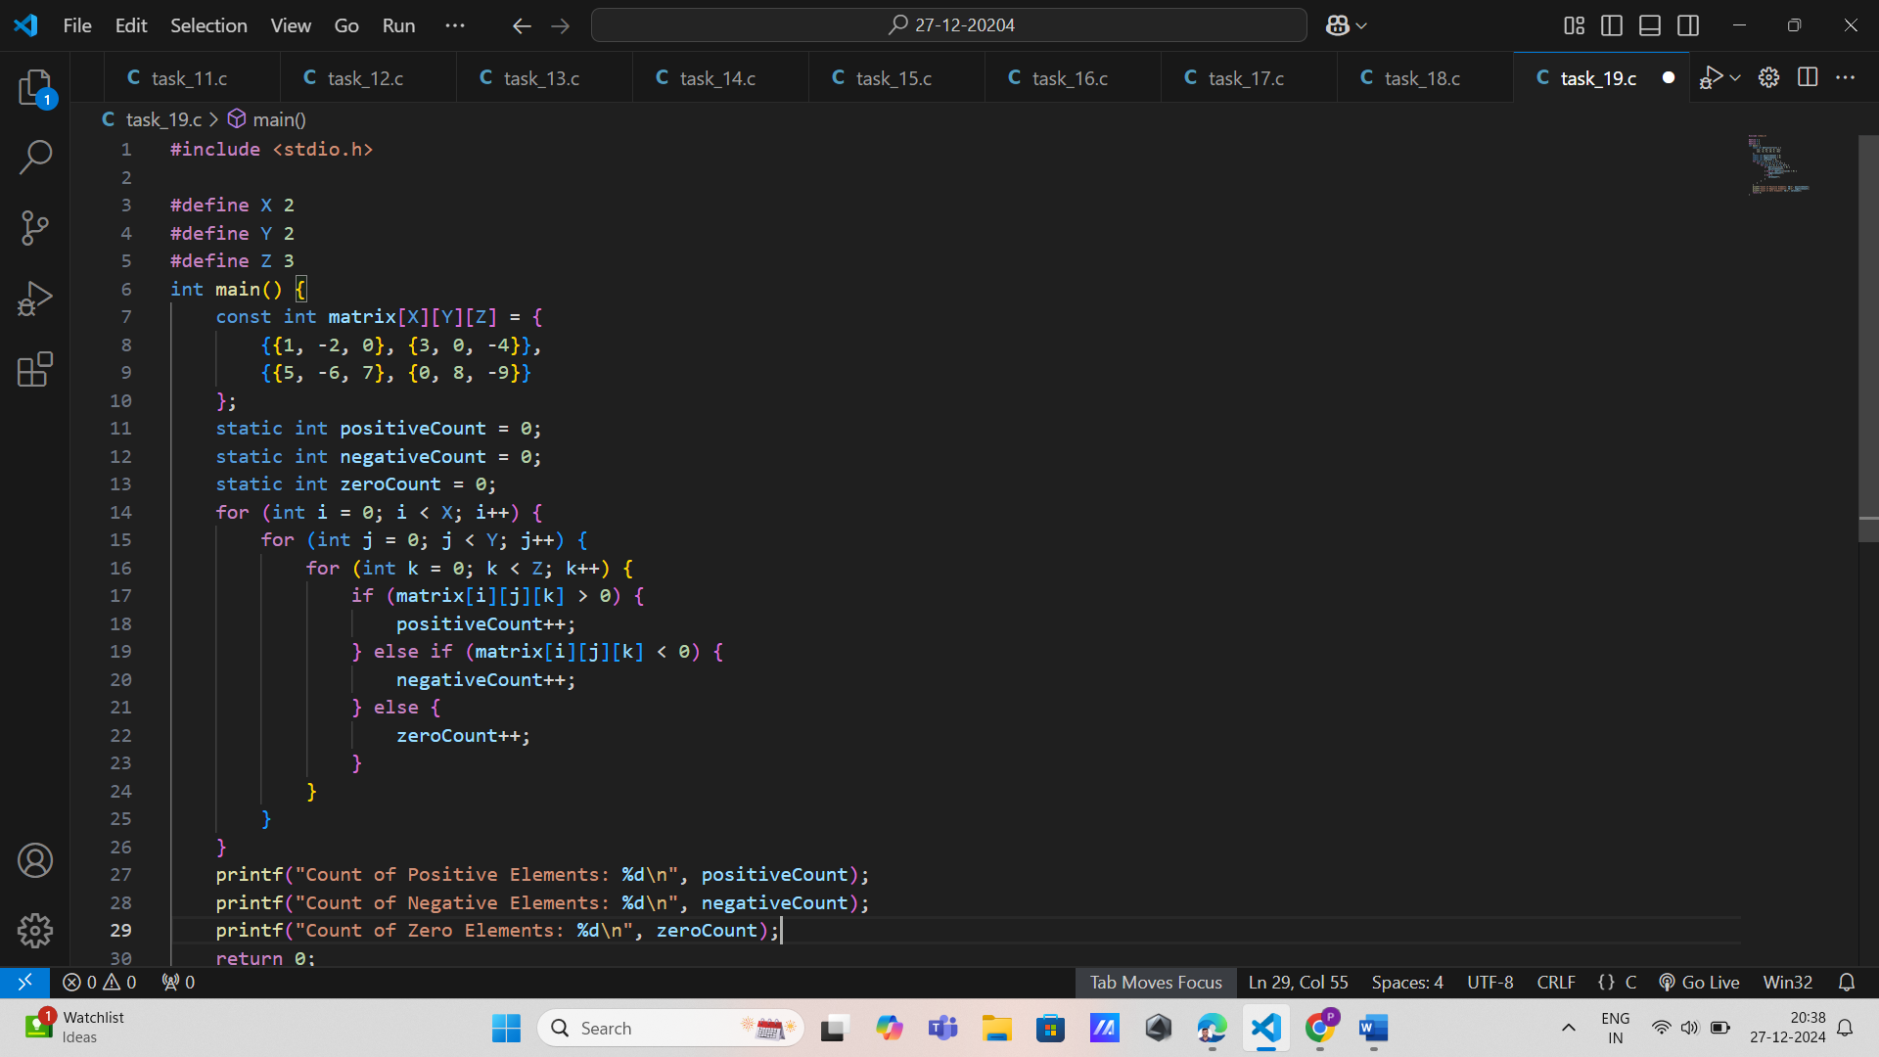

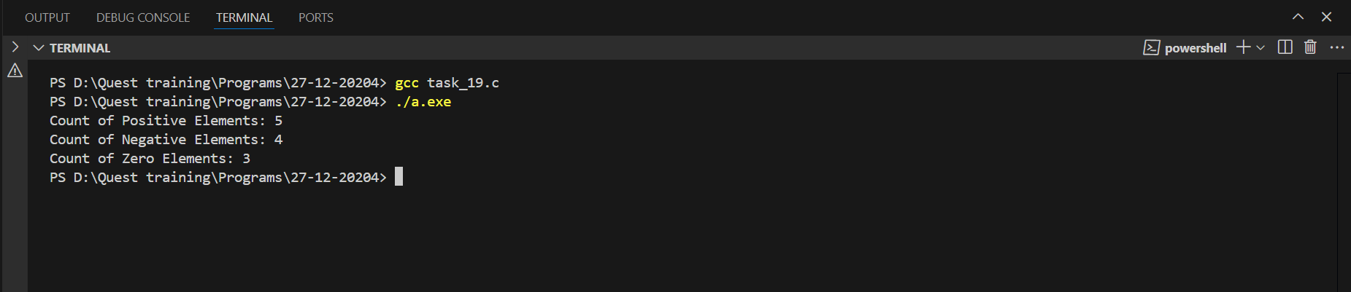

**5. Transpose of a 3D Matrix Along a Specific Axis**

**Problem Statement: Write a program to compute the transpose of a three-dimensional matrix along a specific axis (e.g., swap rows and columns for a specific depth). The program should: Take a matrix of size X x Y x Z as input, where X, Y, and Z are defined using const variables.Use a static three-dimensional array to store the transposed matrix. Use nested for loops to perform the transpose operation along the specified axis. Use if statements to validate the chosen axis for transposition.**

**Requirements: Print the original matrix and the transposed matrix. Ensure invalid axis values are handled using decision-making constructs.**

